## How to run the findDuplicates script on different spreadsheets

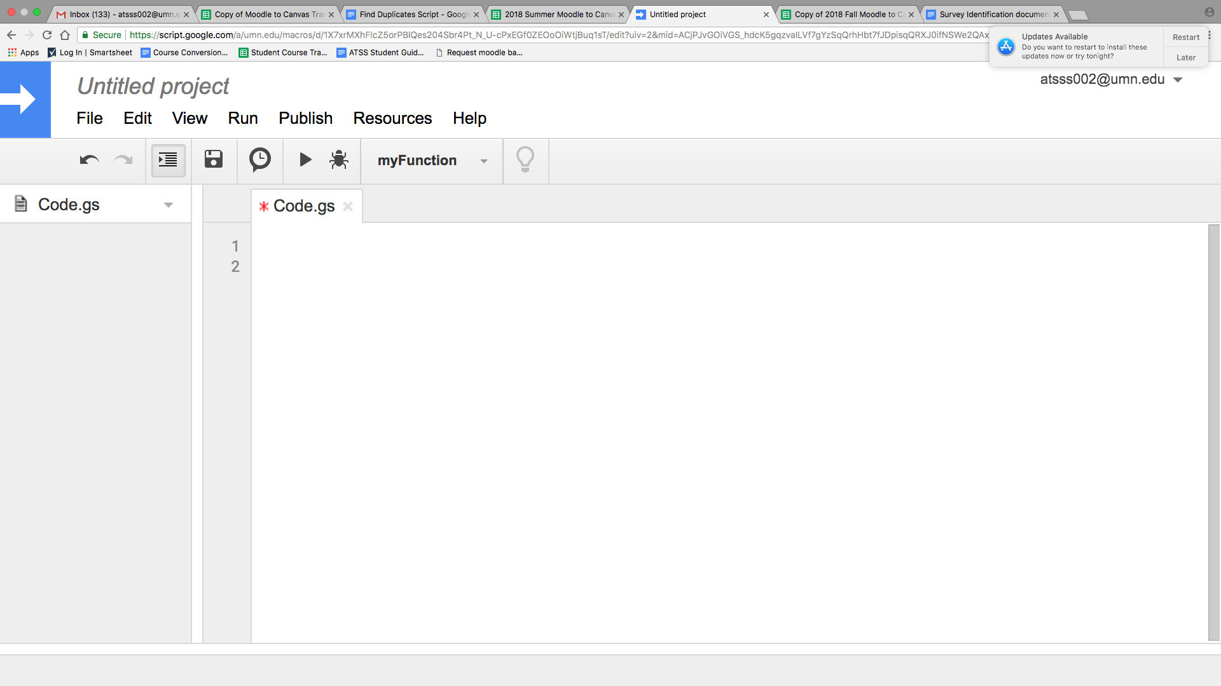

1. Go to tools on the menu bar of the spreadsheet. Below that, click script editor.
2. Once the server is open, clear anything in the script editor then copy and paste the code below.
3. See my comment on how to change the column for each spreadsheet below.
4. Once you’ve made your changes, name the script “findDuplicates” and save.
5. Go to the “Run” option in the menu bar, then click “Run Function”. Afterwards, click both ‘OnOpen’ and 'findDuplicates’ once at a time (It doesn’t matter in which order you do it.)
6. Go back to the spreadsheet, refresh and run the script by clicking the ‘scripts’ option on the menu bar then ‘Find Duplicates’ (please note: the ‘scripts’ option might take a while to show up on the menu bar)

**Copy and paste the below script into the script editor (don't forget to name the script ‘findDuplicates’,save, and run.**

function onOpen() {  
 var sheet = SpreadsheetApp.getActiveSpreadsheet();  
 var entries = [{name : "Find Duplicates",functionName : "findDuplicates"}];  
 sheet.addMenu("Scripts", entries);  
};  
  
function findDuplicates() {  
 var sheet = SpreadsheetApp.getActiveSheet();  
 var dataRange = sheet.getRange("E:E"); // "F:F" is for Column F  
 // And if you want to check duplicates for whole sheet then try:  
 // var dataRange = sheet.getDataRange();  
 var data = dataRange.getValues();//gets all the values in the spreadsheet  
 var numRows = data.length;//rows is the data's length   
 var numColumns = data[0].length;   
  
 var formats = [];//used to give a background color to cells  
 var values = [];  
 for (var i = 0; i < numRows; i++) {  
 formats[i] = [];  
 for (var j = 0; j < numColumns; j++) {  
 formats[i][j] = 'NONE';  
 if (data[i][j] != '') {  
 values.push([data[i][j], i, j]);//adds a new element into the list of data   
 }  
 }  
 }  
 var numValues = values.length;  
   
 for (var m = 0 ; m < numValues - 1; m++) { // all the vals in array of links  
 if (formats[values[m][1]][values[m][2]] == 'NONE') {// if a link doesn't have a duplicate, leave alone  
 for (var n = m + 1; n < numValues; n++) {  
 if (values[m][0] == values[n][0]) {// if a link has a duplicate, change the backgroud color to red  
 formats[values[m][1]][values[m][2]] = 'RED';  
 formats[values[n][1]][values[n][2]] = 'RED';  
 }  
 }  
 }  
 }  
   
 dataRange.setBackgroundColors(formats);  
}